 Daily Report

-

Jira with Rundeck

**www.zippyops.com**

No 209/210, 1st Floor, J Nagar,

4th Cross Street, Panaiyur Kuppam Road,

Panaiyur, Chennai - 600119

**🖂** [**admin@gmail.com**](mailto:admin@gmail.com)

**✆ +91 7010585768, 8903067727**

Contents

**No table of contents entries found.**

My zabbix server is version **4.0.19** and it runs on top of CentOS 7

1. Check the current SELinux status

getenforce

1. Turn off SELinu

setenforce 0

1. download version 0.9.4

curl -L "https://drive.google.com/uc?export=download&id=0B_VNwWso1iSQcGJqamQ1dFVSWWM" -o ~/zabbix-pdf-report-0.9.4.tgz

1. extract 'report' dir

tar -xvzf ~/zabbix-pdf-report-0.9.4.tgz -C /usr/share/zabbix

1. move to the dir report

cd /usr/share/zabbix/report

1. open the config.inc.php file

vi config.inc.php

1. Enter your hostname, zabbix-server user name and password

#$z_server = 'http://localhost/zabbix/';

#$z_user = 'Admin';

#$z_pass = 'zabbix';

1. now move to the page  <http://localhost/zabbix/report>

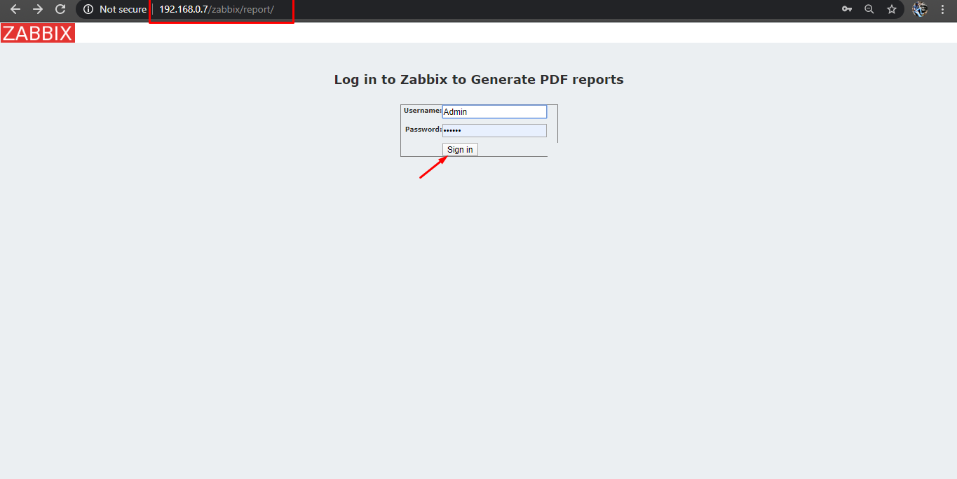

1. Enter the user and password of your zabbix-server
2. Click sign in.
3. Select the host, server name

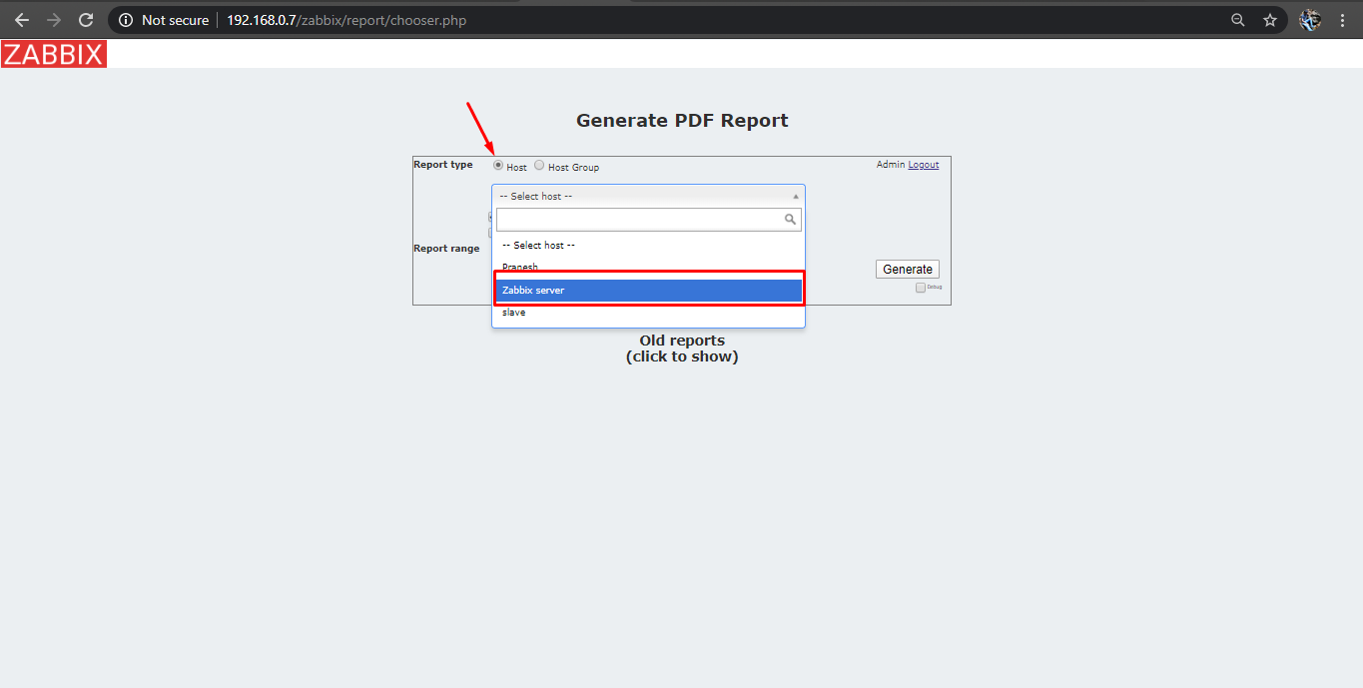

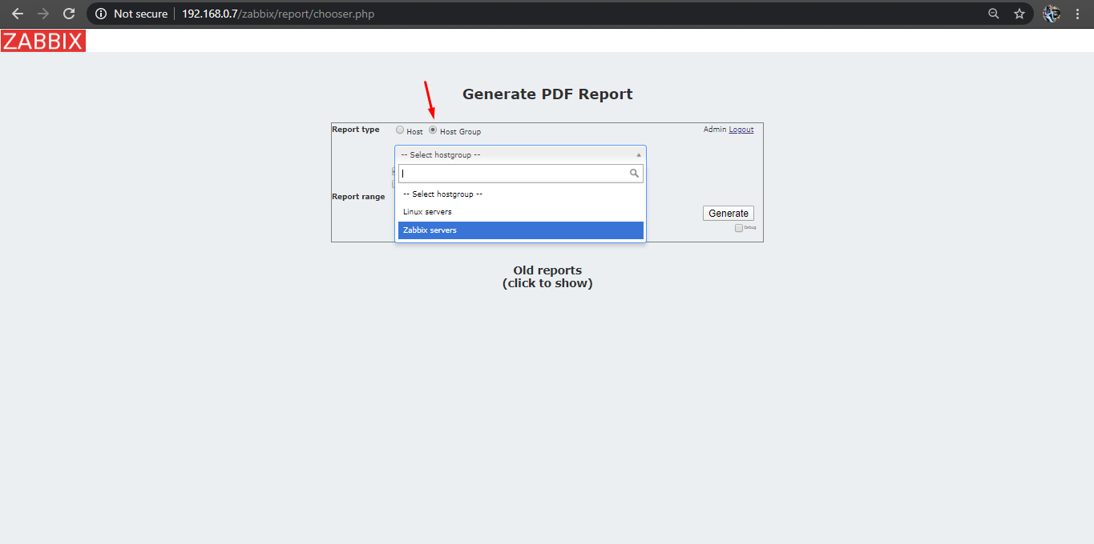

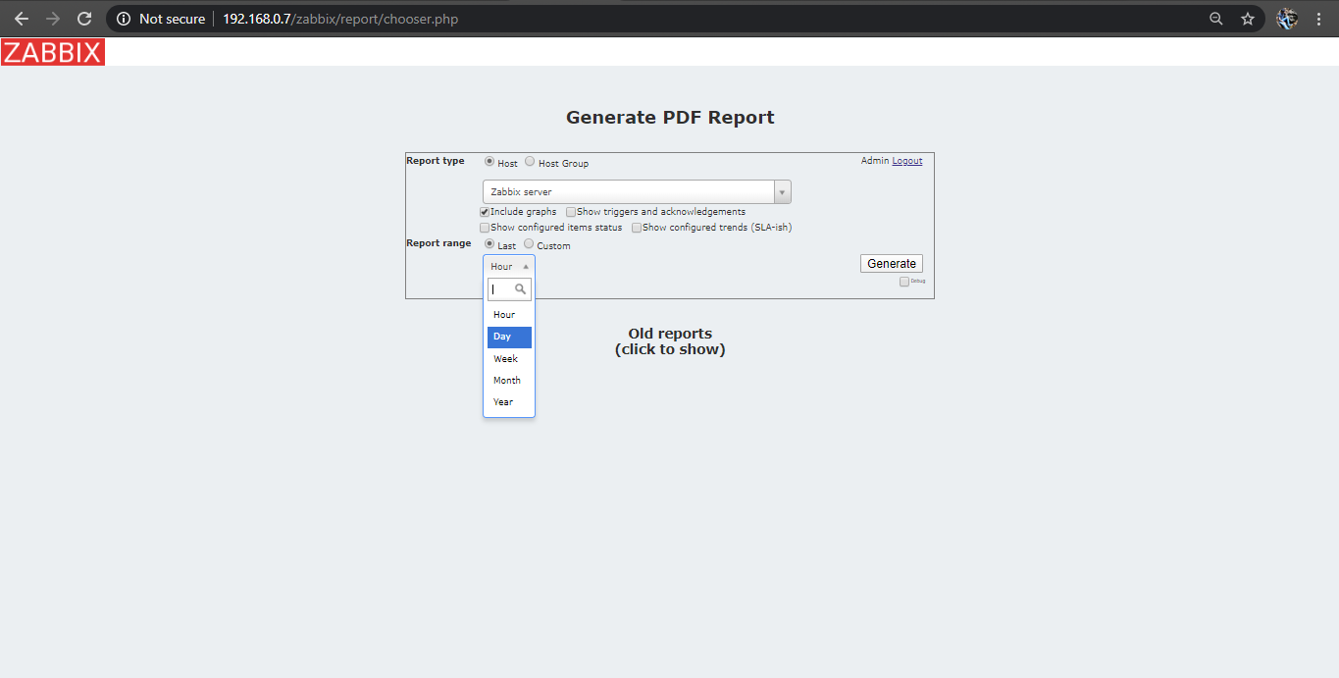

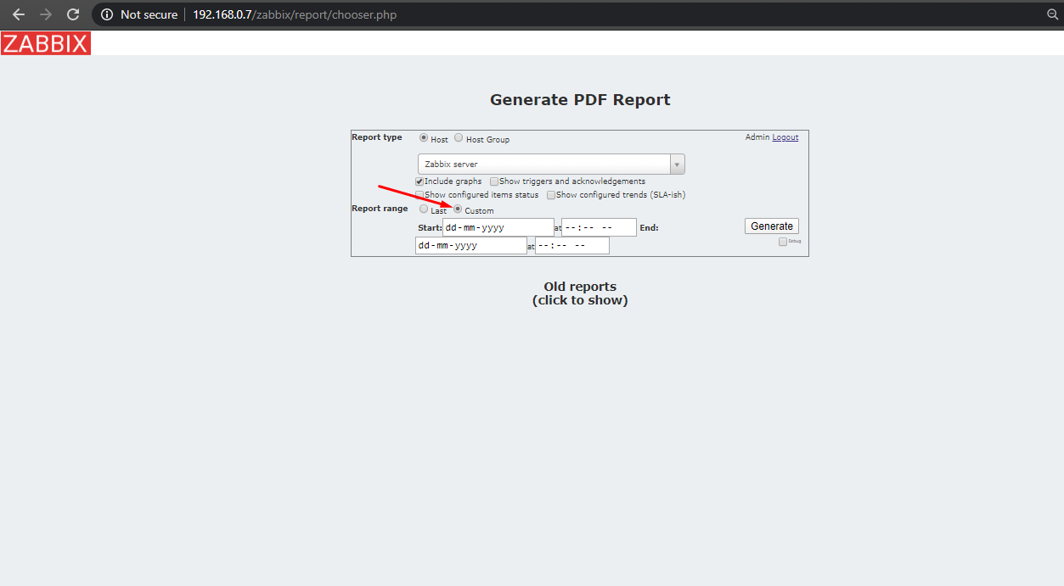

1. Then click generate.

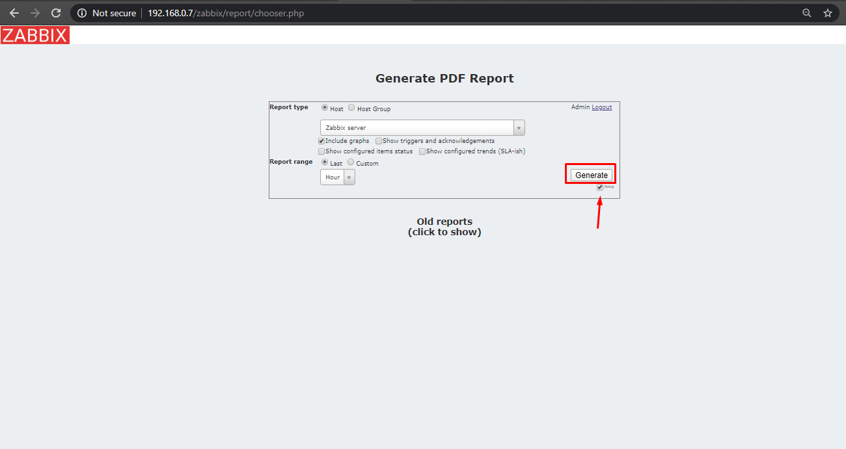

1. PDF will be generated.

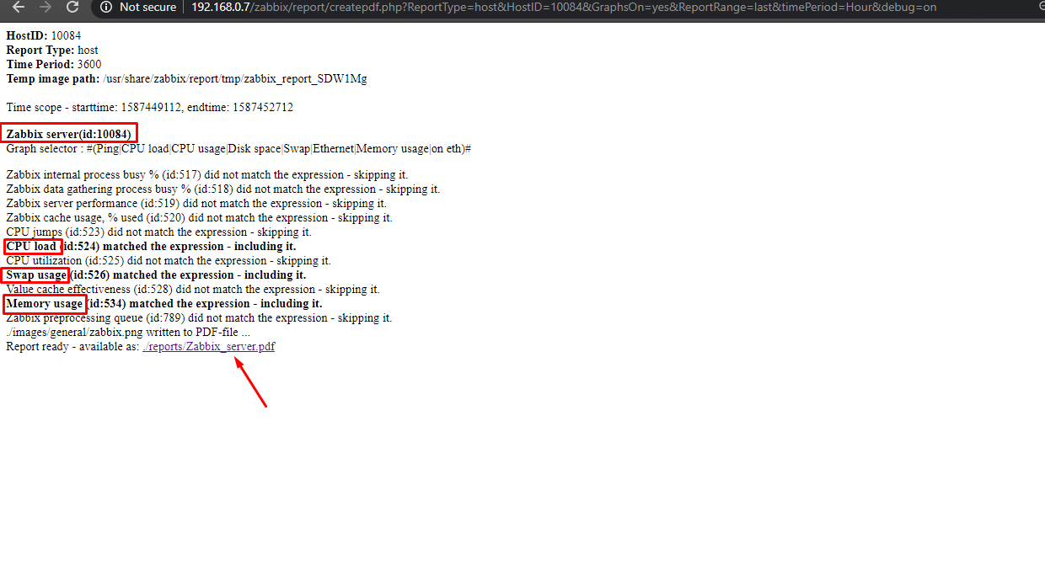

1. The URL of the above page can be used to generate the required pdf.

RUNDECK PART:

1. Create a new project and job , then add the zabbix centos machine as a node in rundeck.

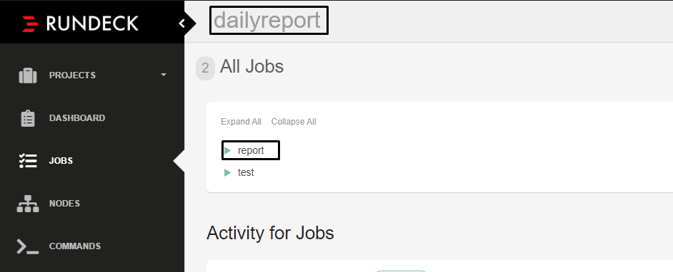

1. Create a folder and the pdf generation script .
2. The script looks like

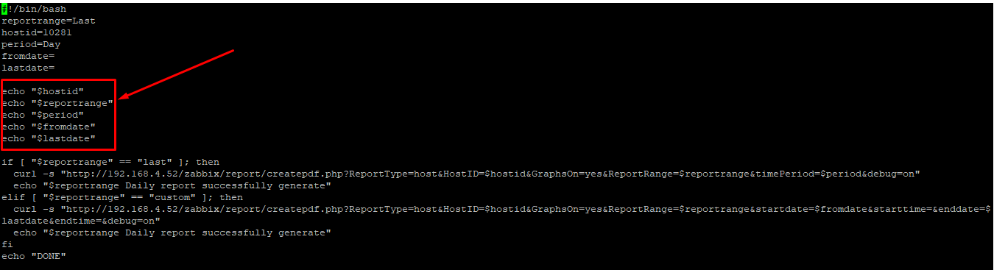

1. The script for sending mail

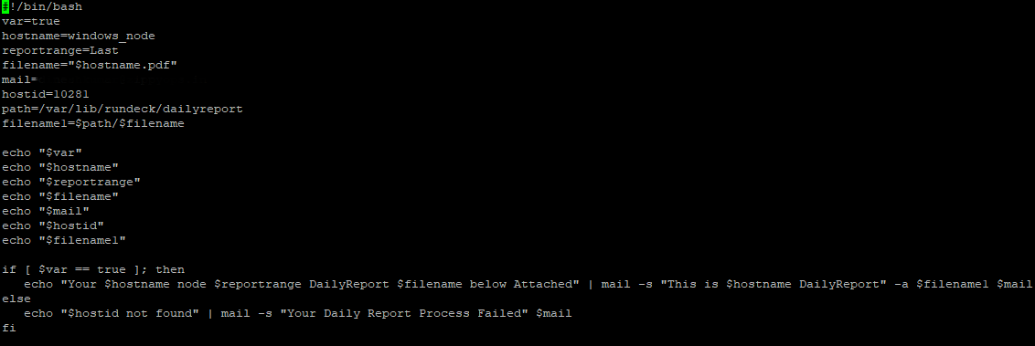

JIRA PART:

STEP1: Create a project and issue.

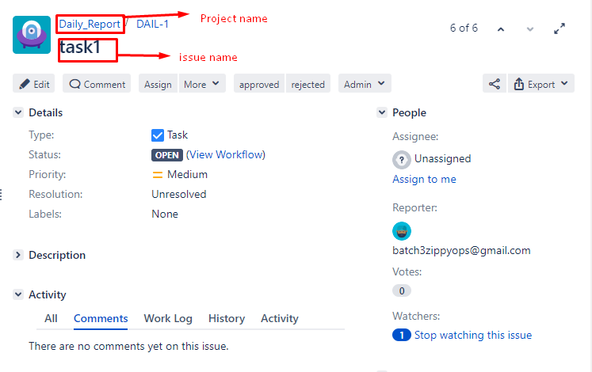

STEP2: Configure Rundeck plugin

a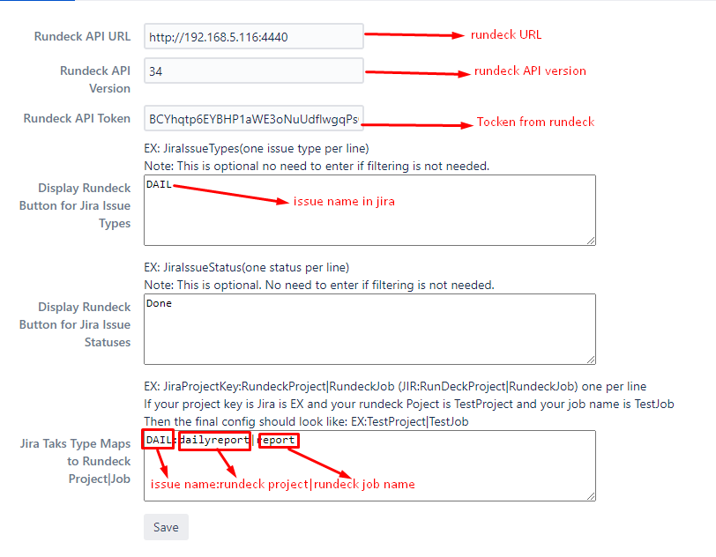

STEP3:Create a Workflow and Add Post function.

1. Select the issues under that click on workflow.
2. Click edit on your desire project name.

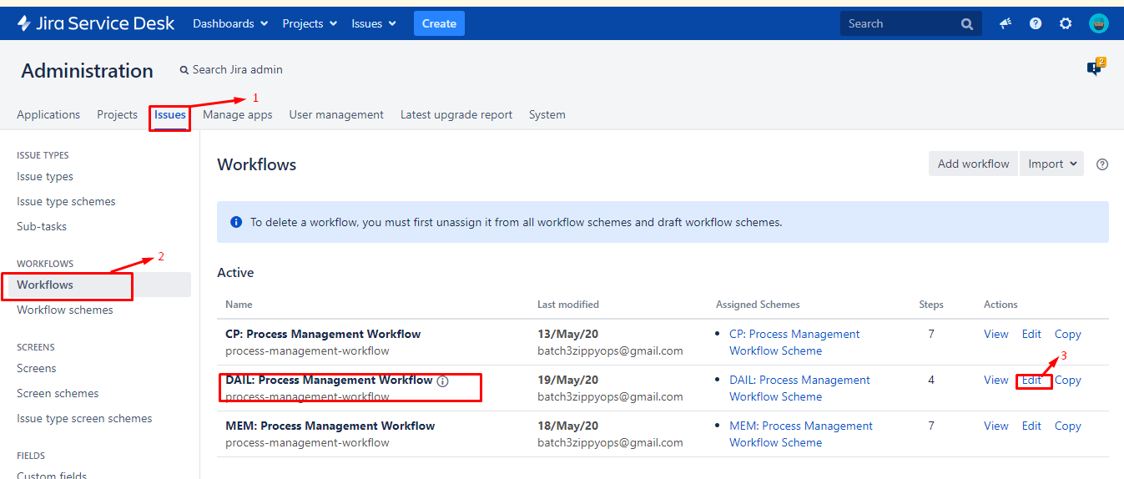

1. Edit the workflow by using the add status and add transition buttons.

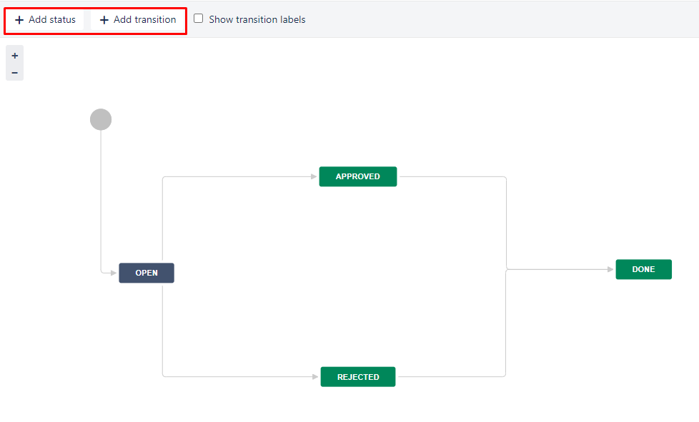

1. Click the show transition labels check box.
2. Then select the approve transition and click the post function button.

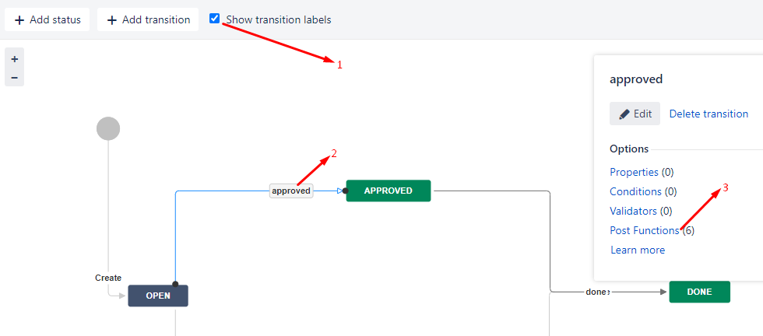

1. Click on add post function.

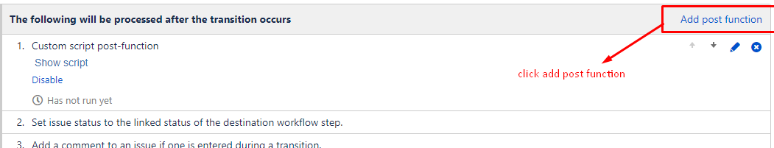

1. Select the script post-function and click add button.

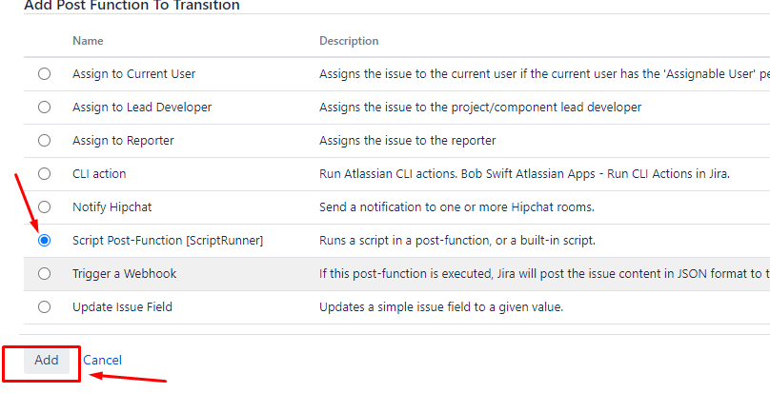

1. Click on the custom script post-function.

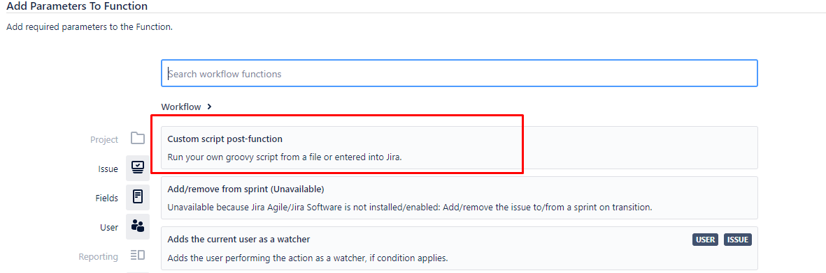

1. Enter the script there in the below formate.

def cmd = "curl -u batch3zippyops:zippyops http://192.168.4.115:8080/plugins/servlet/rundeck?issueKey=${issue.key}"

def proc = cmd.execute()

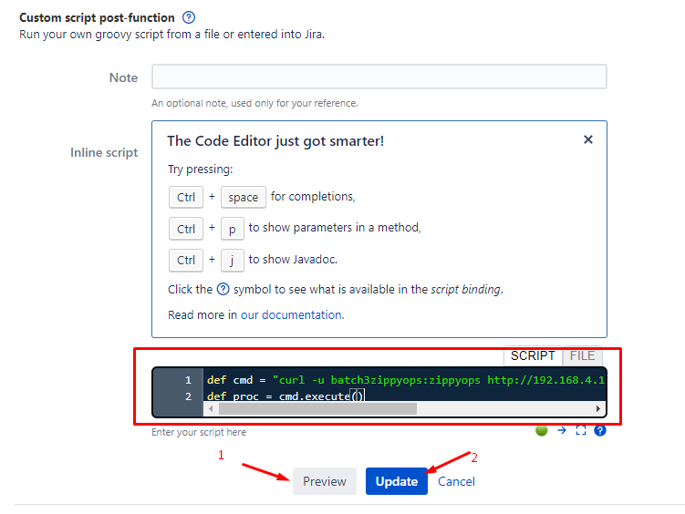

1. Click on preview and then click update.

STEP4:Configure Approval and Rejection Settings.

1. Go to manage apps and select the configuration in the under approval.
2. Click on add button and add the requirments.

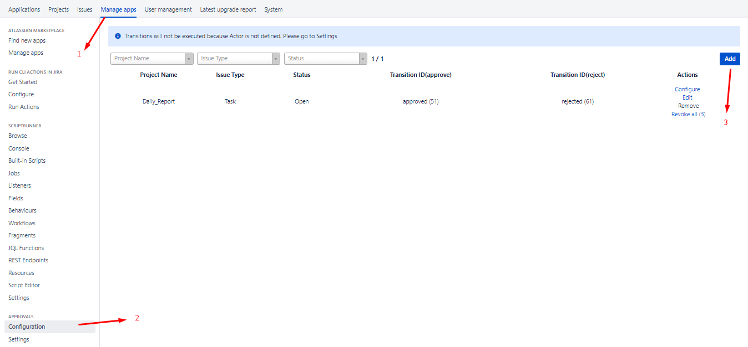

STEP5: Create a custom field.

1. Go to Jira Administration > Issues and Select Custom fields from the menu in the Fields section. Click to Add custom field Depending on the type of custom fields, after Configure the selection criteria for the field. Click to Create.

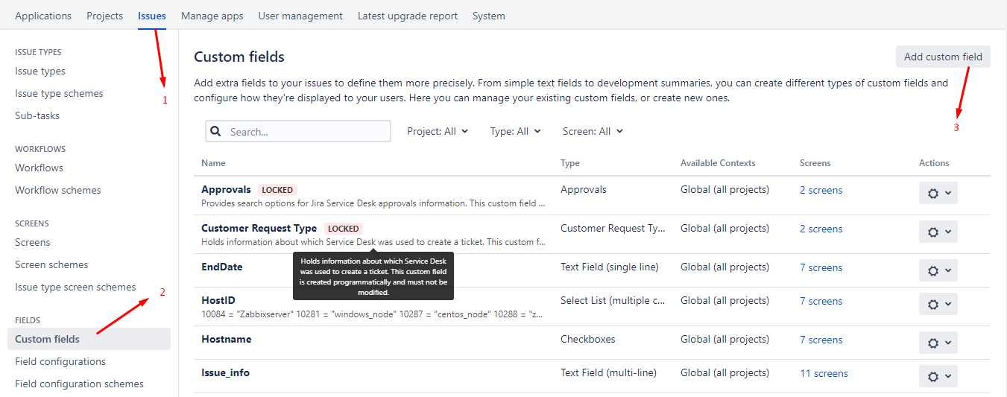

1. Select the custom field u want and then click next then enter the name for it and click ok

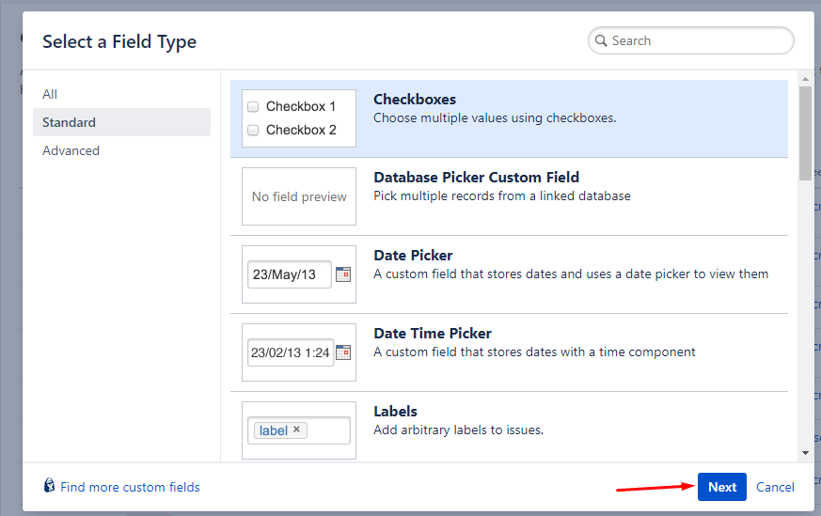

RUNDECK PART:

1. Enter the following scripts in the desire path.
2. Script for the selection of host id and hostname.

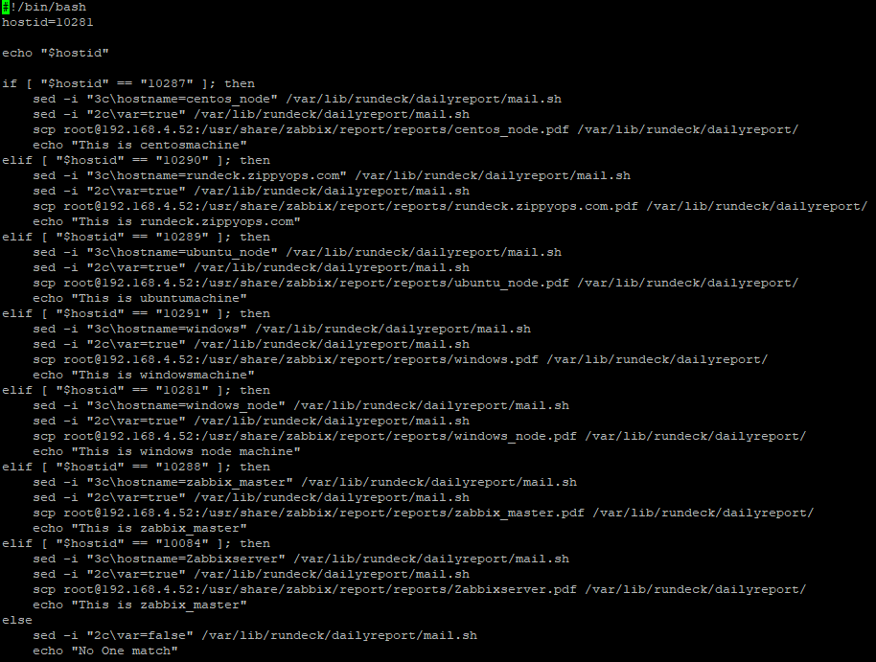

1. Script to generate pdf from the zabbix machine .

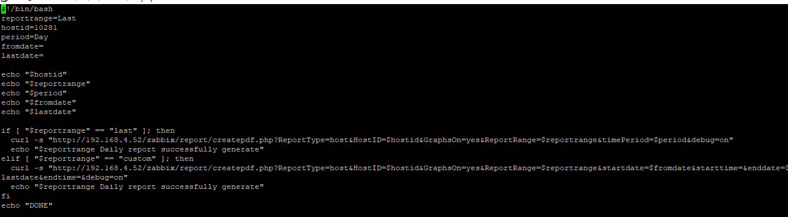

1. Script to get the generated pdf to the rundeck machine.

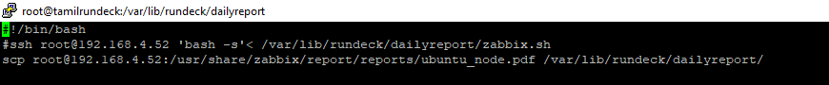

1. Script to send the copied pdf to the corresponding mail.

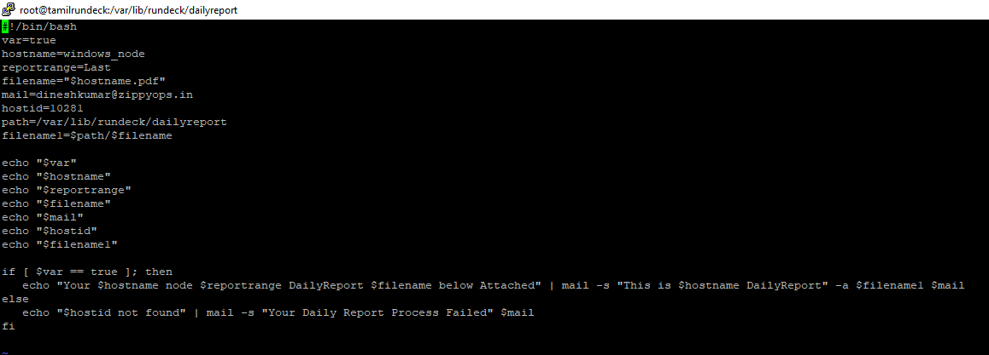

1. Create workflow in the job you have created ,in the correct order to run the shellscript files by using set command.

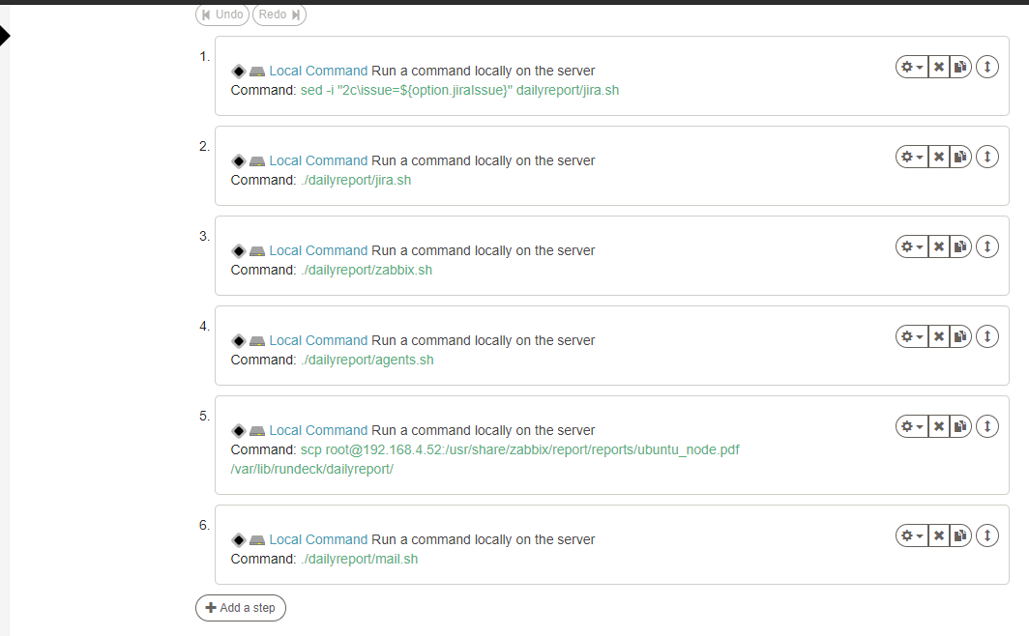

JIRA PART :

1. Go to JIRA and create a net issue in your project there will be list of custom field where you can enter the issue name and the required details and the receiver mail.

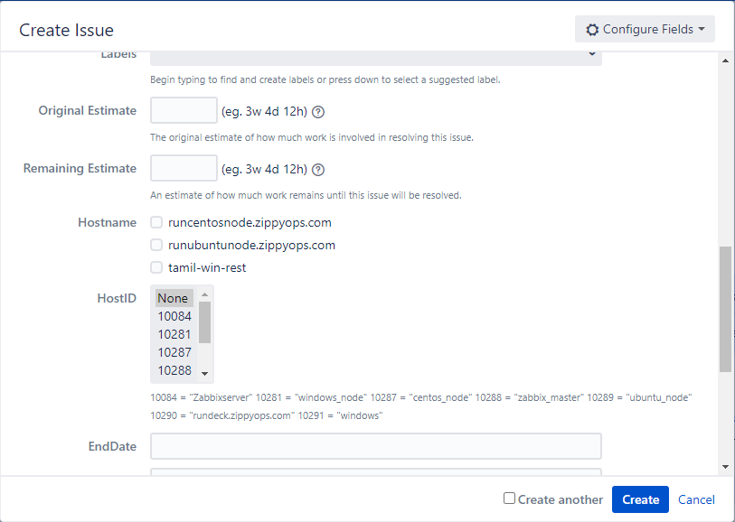

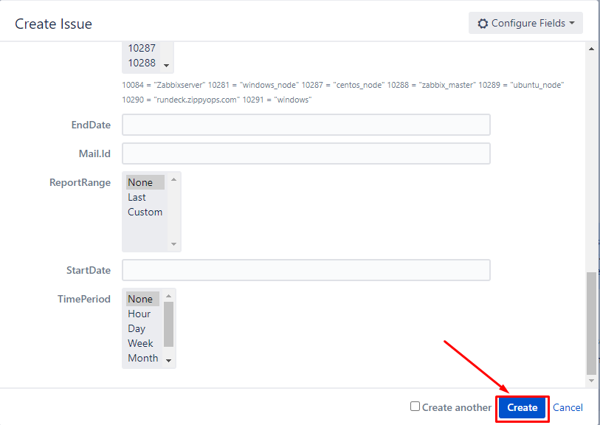

After entering the details then click the create button.